CHAPTER 907
PLANTINGS IN STREET RIGHT-OF-WAY AND OTHER VILLAGE PROPERTIES
907.01 DEFINITIONS.
For the purposes of this chapter, the following terms, phrases, words and their derivatives shall have the meaning given herein:
(a) "Arborist" means a professional person whose certified area of expertise is forestry, horticulture and the selection and maintenance of trees, and other plantings.
(b) "Basal clearance" means the distance from the center of a tree to the drip line of the tree at maturity. This distance will not change with time for any given tree, but it will vary from species to species.
(c) "Canopy" means the cumulative horizontal crown at the widest point of a tree.
(d) "Evergreen" means trees that remain green and do not lose their leaves.
(e) "Critical Root Zone (hereinafter 'CRZ')" means the area surrounding a tree or planting wherein are the major roots of the tree or planting. In many, but not all species, this coincides with the extension of the tree canopy or basal clearance.
(f) "Curb lawn" means the area in the public way between the sidewalk and curb or edge of roadway or between the abutting property lines where there is no sidewalk.
(g) "Deciduous trees" means trees that lose their leaves in winter.
(h) "Ground operated equipment" means any utility-related owned and operated devices or access points installed at or near ground level including but not limited to pad- mounted transformers, switch boxes, manhole covers, pull boxes, gas and/or water valves, and fire hydrants.
(i) "Habitat" means a living environment that supports the survival needs of life, including shelter, water and food. Trees and plantings are a key component of the habitat of most species.
(j) "Native trees" means trees that are indigenous and original to a particular geographical area.
(k) "Person" means any person, firm, partnership, association, corporation, company, or organization of any kind.
(l) "Plantings" means trees, shrubs, and any other vegetative materials that may exceed three (3) feet in height.
(m) "Political subdivision” means a municipal corporation, county, school district, or other body corporate and politic responsible for governmental activities in a geographic area smaller than that of the State.
(n) "Private land" means areas located within the Village of Golf Manor that are owned by a private person and/or entity and that are not owned by any political subdivision.
(o) "Public land" means property or areas located within the Village of Golf Manor that are owned by the Village of Golf Manor or any other political subdivision, including but not limited to streets, rights-of-way, public ways, and parks.
(p) "Public nuisance" means any tree or other planting with an infectious disease or insect problem or dead or dying trees or plantings; or a tree or limb(s) or plantings that obstruct the sight triangle of street lights or traffic signs or the free passage of pedestrians or vehicles; or any tree or other planting that obstructs or interferes with public utilities; or a tree or planting that poses a threat to the public health, comfort, safety, and welfare, as determined by the Village Administrator's designee.
(q) "Public way" means any public street, road, highway, public easement, sidewalk, alley, curb lawn, or public waterway, and includes the entire width of any right of way or easement when any part thereof is open to the use of the public, as a matter of right, for purposes of vehicular and/or pedestrian traffic.
(r) "Shade trees" means woody plants having a single, well-defined stem, a more or less definite crown, a height of not less than thirty (30) feet and a trunk diameter at maturity of not less than six (6) inches, planted primarily for the purpose of providing shade.
(s) "Shrubs" means woody plants generally with no single well-defined stem used as accent, border or foundation plants.
(t) "Street trees" means trees planted in the public way.
(u) "Tree" means woody plants having a single, well-defined stem, as indicated by subsequent provisions of this chapter.
(v) “Topped or Dehorned trees" means trees with most or all of the crown removed.
(w) "Tree inventory" means a summary of data collected to document the trees in the community using accepted statistical techniques. For purposes of this chapter, a tree inventory shall include the tree count and tree species, size and condition.
(x) "Tree size" means:
(1) Utility zone plantings. Any tree reaching a mature height of less than twenty-five (25) feet.
(2) Small tree. Any tree reaching a mature height of less than thirty (30) feet.
(3) Medium tree. Any tree reaching a mature height of thirty (30) to forty-five (45) feet.
(4) Large tree. Any tree reaching a mature height of over forty-five (45) feet.
(y) "Urban forest" means the sum of all trees, shrubs, and plantings found in and around dense human settlement, including all trees, shrubs, and plantings found in parks, cemeteries, public lands, private lands, and public ways.
(z) "Utility zone" means the area under, over, and/or adjacent to owned utilities including but not limited to, utility poles, manhole covers, lighting fixtures, transformers, and switch enclosures.
907.02 ADMINISTRATION OF REGULATIONS.
(a) In the case of trees standing on Village grounds or easements, no person shall cut, trim, mutilate, injure or destroy any tree without first having obtained permission to do so from the Village Administrator or his/her designee. However, nothing in this section shall be construed to prohibit the trimming or cutting by the Village of trees or parts thereof on or extending over any street or other ground belonging to the Village when such trimming or cutting is necessary to prevent interference with any Village-owned or private utility, or to remove any dangerous condition, or for any other Village purpose.
(b) The Village Administrator shall designate an individual to be responsible for the administration of this chapter. This individual may or may not be an arborist but shall have knowledge of the care and maintenance of urban forests.
(c) In addition to the authority granted the Village Administrator, the designee is hereby authorized to enforce Sections 907.04 through and including Section 907.06 of this chapter.
907.03 STANDARDS FOR PLANTING AND MAINTENANCE IN THE PUBLIC WAY.
(a) All plantings shall be subject to the final approval of the Village Administrator's designee.
(b) All plantings shall be in a live, healthy condition.
(c) Specified varieties of any species shall be specimen-type trees or shrubs and shall be graded according to the applicable American National Standards Institute (ANSI) for Nursery Stock or better and shall be first class representatives of their normal species and varieties.
(d) The approved list is maintained in the Village of Golf Manor and prohibited species and cultivars for planting in or adjacent to the public way are listed in Section 907.07 hereof. In order to maintain consistency with horticultural practices, the list set forth in Section 907.07 may be reviewed and revised by the Village Administrator without further legislative approval. Any such revision of the list of plantings shall be effective only upon the written approval of the Village Administrator.
(e) Distances and Clearances.
(1) Plantings within the public ways that impact traffic safety shall be coordinated with and approved by the Village Administrator’s designee. The following criteria shall be used as guidelines with regard to plantings that impact traffic safety:
A. A minimum of thirty-five (35) feet from the nearest street corner measured from the point of the nearest intersecting curbs or curblines.
B. A minimum of fifteen (15) feet from driveways.
C. A minimum of twenty (20) feet from alleyways.
(2) Plantings within the Utility Zone shall be installed using the following criteria:
A. Only species listed for use in Utility Zones shall be planted under utility lines or within ten (10) lateral feet of said lines.
B. A minimum of a fifteen (15) foot clearance from ground operated equipment.
C. A minimum of a fifteen (15) foot clearance shall be maintained from streetlight fixtures to any plantings or portion thereof, which obstructs the path of light.
D. A minimum of a fifteen (15) foot distance from fire hydrants.
(3) Trees within the public ways shall be maintained so that:
A. Branch clearance above sidewalks shall be eight (8) feet or greater.
B. Branch clearance above streets shall be fifteen (15) feet or greater. The Utilities are under no obligation to safeguard plantings made in the utility zone. However, compliance with these guidelines should minimize the effects of utility operations on subsequent additions to the urban forest.
(f) Except for plantings planted and maintained by the Village or other approved public authority, only the plantings listed in Section 907.07, or any other plantings that may be hereafter approved or prohibited and approved in writing by the Village Administrator, may be planted in the public ways.
(g) All stumps and remnants of street trees must be removed twelve (12) inches below the ground surface so that the top of the stump/remnant shall not project above the surface of the ground.
(h) Sidewalk street repairs that will potentially endanger street trees shall require prior consultation with the Village Administrator's designee as to the best way to protect the tree roots where possible in the opinion of the Village Administrator's designee.
(i) The Village Administrator’s designee shall approve the tree plan for any Village curb lawns.
(1) Tree spacing. The spacing of public trees will be in accordance with the three (3) species size classes referred to in the list of street trees and no trees may be planted closer together than the following (except in special plantings designed or approved by the Village).
Small trees 30 feet
Medium trees 40 feet
Large trees 50 feet
(2) Distance from curb and sidewalk. The distance public trees may be planted from curbs or curblines and sidewalks will be in accordance with the three (3) species size classes in the list of street trees and no trees may be planted closer to the curb or sidewalk than the following (except in special plantings designed or approved by the Village).
Small trees Two feet (minimum of a four-foot wide treelawn)
Medium trees Three feet (minimum of a six-foot wide treelawn)
Large trees Four feet (minimum of an eight-foot wide treelawn)
907.04 RESPONSIBILITY FOR MAINTENANCE OF PLANTINGS IN OR OVERHANGING THE PUBLIC WAY.
(a) Plantings shall be established and maintained in and adjacent to the public ways along streets in accordance with the provisions of this chapter. Plantings not so established and/or maintained are hereby declared to be public nuisances, except that existing plantings that are maintained in accordance with ordinances existing on the effective date of adoption of this chapter shall not be considered public nuisances.
(b) It shall be the duty of all property owners and occupants to trim or remove plantings in the public ways abutting their property that are not maintained in accordance with the requirements of this chapter.
(c) The Village Administrator's designee or any designated member of his/her staff shall have the authority to enter upon private land at any and all reasonable times to examine any tree, shrub, or other planting located upon or over such private land and to carry out the provisions of this chapter.
(d) The Village Administrator's designee under Section 907.03 shall cause written notice to the property owner(s) and occupant(s) to trim or remove any planting within, or adjacent to, the curb lawn area of the abutting public ways that do not conform with the provisions of this chapter. Such notice shall be sent by certified mail, return receipt requested, to the tax mailing address of the property owner(s) of record with the Hamilton County, Ohio, Auditor and to the occupant(s) at the address of the property. If certified mail is returned unclaimed, notice will be sent by regular mail.
(e) If the planting is not trimmed or removed within the time period stated in the written notice, not less than ten (10) days from date of receipt of the notice, the Village Administrator's designee may cause such trimming or removal to be undertaken and the reasonable costs thereof shall be the responsibility of the abutting property owner(s) and occupant(s). Reasonable costs shall include, but not be limited to the time of personnel involved, cost of fuel, cost of machinery, and the size, nature or character of the lot or parcel of land, as well as any and all other expenses for the performance of such labor and services provided, including an administrative fee of two hundred dollars ($200.00). If the use of a contractor is required, the Village will be reimbursed the cost paid to the contractor plus administrative fees.
(f) Repeat Violators. For the second or continued violations of the same general character, on property whereby the owner(s) or occupant(s) notice under subsection (d) hereof, occurring not sooner than fourteen (14) days and not later than two (2) years after the previous violation, the written notice contained in subsection (d) hereof may be omitted and a violation notice, specifying that the violation shall be corrected within seventy-two (72) hours of receipt of said violation notice, shall be personally served upon the owner(s) or occupant(s) as specified in subsection (d) hereof, or posted on the premises if the owner(s) or occupant(s) cannot with reasonable diligence be located. If the violation is not corrected by the specified compliance date by the owner, occupant or other person or entity under subsection (d) hereof, the Village shall cause such trimming or removal to be undertaken at the expense of the owner of that land, and may employ the necessary reasonable costs as outlined in subsection (e).
(g) In the event that the property owner(s) and occupant(s) fail to remit such costs to the Village within thirty (30) days after written notice of the amount of such costs, the Village Fiscal Officer may certify such costs to the Hamilton County Auditor to be entered upon the tax duplicate for the abutting property as a lien and collected as other taxes and returned to the applicable Village fund.
(1) In the event that the Village certifies the expenses incurred to the Auditor of Hamilton County to place them on the tax duplicate for collection as a Special Assessment, an additional charge of Fifty Dollars ($50.00) shall be assessed for the purpose of defraying the cost of certification.
(h) In the event that a planting within the public way presents imminent danger to public safety, it may be trimmed or removed by the Village without written notice to the property owner. The property owner shall be responsible for the costs thereof as provided in subsection (e) hereof.
907.05 PROHIBITIONS.
(a) No person, firm, or corporation shall do any of the following:
(1) Fail to perform any requirement contained in this chapter or commit any act prohibited in this chapter.
(2) Fail to trim or remove any planting within or abutting the public way to the property after receiving written notice in accordance with Section 907.05(d).
(3) Fail to pay the costs of trimming or removing any planting within the abutting curb lawn area of public way of the property.
(4) Excavate or significantly disturb the earth within a radius of ten feet of any tree within the public way or on public land without first obtaining written permission from the Village Administrator's designee under this chapter.
(5) Top (de-horn), remove, or girdle any healthy tree in the public way or other public land without prior written approval from the Village Administrator or his/her designee. Trees severely damaged by storms and needing to be trimmed or removed in the interest of public safety are exempted from this section. Trees damaged by insects, diseases or certain trees under utility wires or other obstructions may be removed with the approval of the Village Administrator or his/her designee. Contractors involved in utility line pruning are exempted from this section; however, line pruning must be done in accordance with the guidelines set forth in the publication standard.
(6) Recklessly cause direct or indirect damage to a tree or other planting in the public way or on public land through any of the following means:
cutting, carving, transplanting, removing, attaching rope, wire or nails, or advertising posters; pouring harmful liquids or harmful chemicals on the tree or other planting or in or near CRZ;
setting fire to or near a tree or other planting; impeding water, air or fertilizer to a tree or other planting.
(b) This section does not apply to political subdivisions or their agents, employees, or subcontractors.
907.06 APPROVED AND PROHIBITED PLANTINGS IN OR ADJACENT TO THE PUBLIC WAY.
(a) The following are the plant forms approved for planting in and adjacent to the public way:
(1) Lawn grass, not to exceed 8".
(2) Ornamental grasses or flowers not to exceed 18".
(b) The species and varieties of deciduous shade trees approved are as follows:
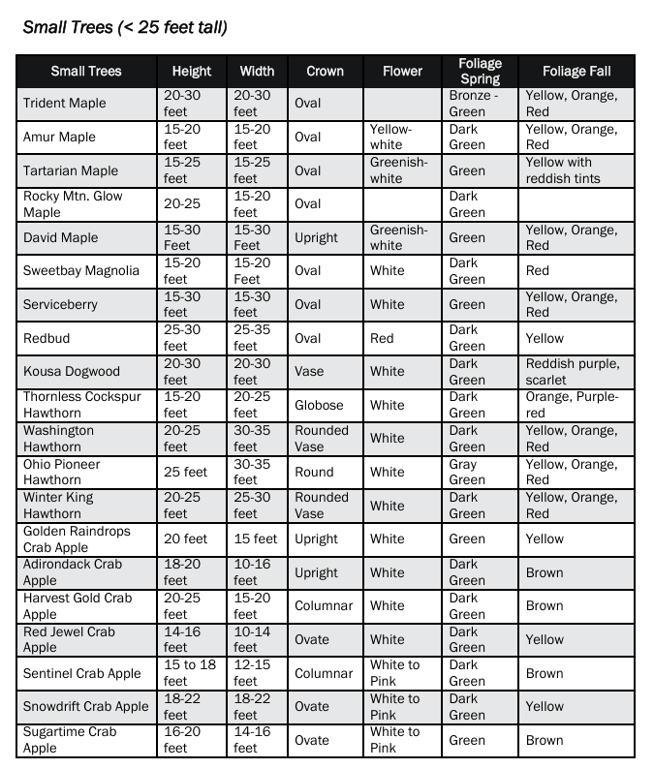

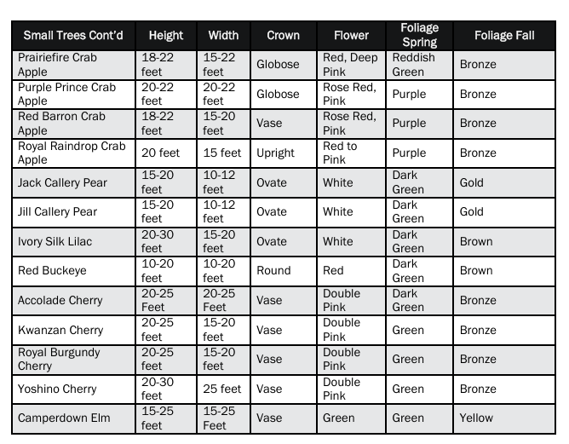
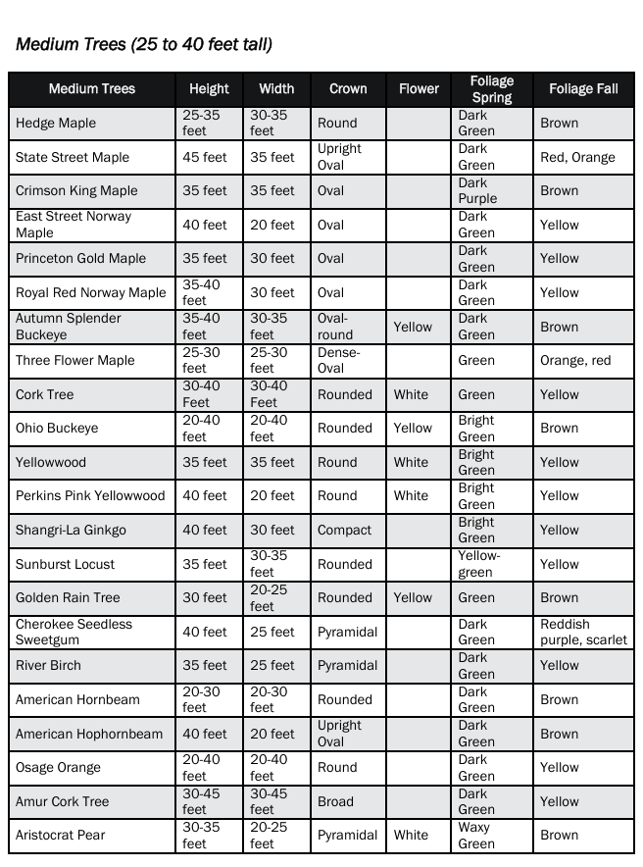
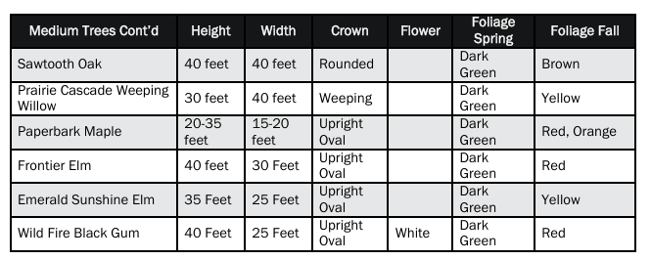
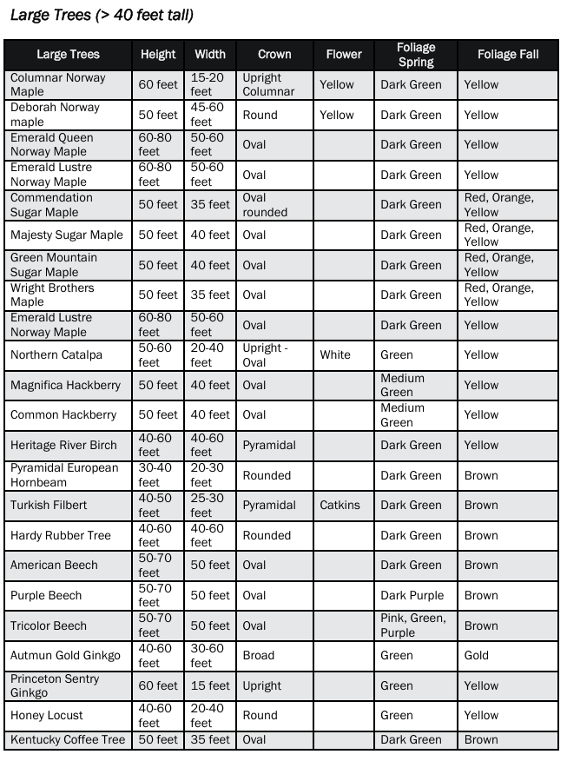
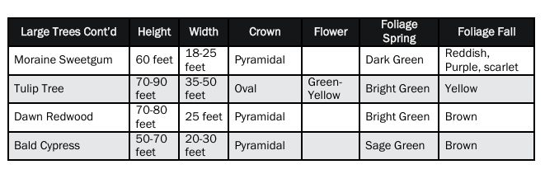

The prohibited list for planting in and adjacent to the public way are listed below in Section 915.07(c) and (d).
(c) Trees Prohibited in Public Way Areas (Prohibited Street Trees).
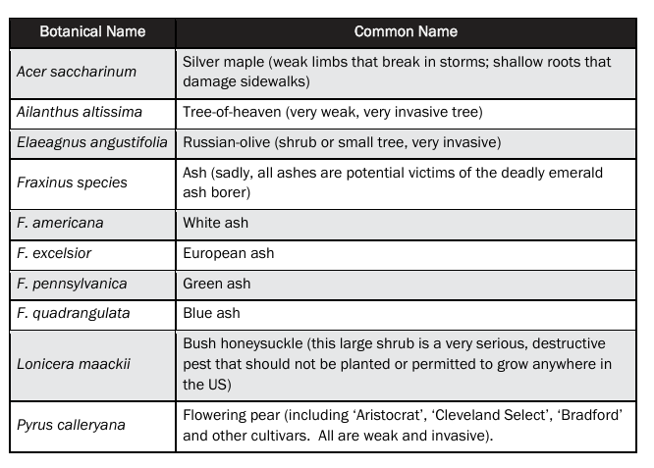

(d) Prohibited manipulations of plantings in or adjacent to the public way include:
(1) Espaliers or topiary: Forms achieved through trimming or pruning that are distorted or contrary to the natural shape of the species.
(2) Shrubs: Shrubs that typically grow taller than three feet, yet not tall enough to be under trimmed to a height of six feet.
(3) Topped or dehorned trees: Trees with most of or the entire crown removed.
(e) The plantings listed in paragraph (a) through (d) above may be modified or revised from time to time upon the written approval of the Village Administrator.
907.07 GUIDELINES FOR REMOVAL OF TREES IN PUBLIC RIGHT OF WAY (CURB LAWNS).
(a) A form, "Request for Removal Tree(s) Located in the Public Way," must be completed with the necessary details for the Village Administrator's designee to do an inspection and render a decision.
(b) A tree that is dead or dying (50% or more) must be removed upon review and approval by the Village Administrator's designee.
(c) Any tree that has outgrown its planted area and is causing damage to the bordering sidewalk or curb may be removed upon the review and approval of the Village Administrator's designee, who shall determine the reasonableness of replacing the sidewalk versus removing the tree. Replacement of either is responsibility of the property owner.
(d) A tree that is affecting a sanitary sewer line from a building shall be considered for removal only after all other methods of sewer line maintenance have been attempted (i.e. root pruning, boring the line). Documented proof of such action has to be presented to the Village Administrator's designee before a request for removal will be considered.
(e) A tree may be considered for removal if it is affecting other trees in such a way that the growth needs to be thinned or if the branches are affecting utility lines, is growing too close to a utility pole, or is growing too close to another immovable obstruction (e.g., a flagpole).
(f) A tree that is a nuisance due to its natural state shall not serve as the basis for removal, subject to the appeals procedure set forth in Section 907.08.
907.08 APPEALS.
(a) Any person aggrieved (the "appellant") may appeal the denial of the request referenced in Section 907.07 to the Village Administrator by filing a written notice of appeal with the Village Administrator no later than ten days after the date of such denial. The notice of appeal shall include the complete name, address, and telephone number of the appellant, the date and description of the denial, and a statement of the grounds for appeal, which shall include the detailed reasons for reconsidering the request and overturning the denial. Upon receipt of the notice of appeal, the Village Administrator shall schedule a hearing to take place no later than thirty days after receipt of the notice of appeal. The Village Administrator shall notify the appellant, in writing, of the hearing date. The Village Administrator shall hear evidence and argument regarding the appeal and shall thereafter render a decision and so notify the appellant.
(b) The Village Administrator shall render a written decision within thirty days of the hearing. The decision of the Village Administrator shall be final.
907.09 DESTRUCTION OF SHRUBS, TREES, OR CROPS.
(a) No person, without privilege to do so, shall recklessly cut down, destroy, girdle, or otherwise injure a vine, bush, shrub, sapling, tree, or crop standing or growing on the land of another or upon public land.
(b) In addition to any penalty provided, whoever violates this section is liable in treble damages for the injury caused.
907.99 PENALTY.
Whoever violates any provision of this chapter is guilty of an unclassified misdemeanor and shall be fined not more than two hundred and fifty dollars ($250.00). A separate offense shall be deemed committed each day during or on which an offense occurs or continues.

